Software Requirements Specification

**For**

Broadway Courier Services (Courier Management System)

**Version 1.0**

# Table of Contents

Table of Contents ii

Revision History iii

1. Introduction 1
   1. Purpose 1
   2. Document Conventions 1
   3. Intended Audience and Reading Suggestions 1
   4. Product Scope 1
   5. References 2
2. Overall Description 2
   1. Product Perspective 2
   2. Product Functions 2
   3. User Classes and Characteristics 2
   4. Operating Environment 3
   5. Design and Implementation Constraints 3
   6. Assumptions and Dependencies 3
3. External Interface Requirements 4
   1. User Interfaces 4
   2. Hardware Interfaces 4
   3. Software Interfaces 4
   4. Communications Interfaces 4
4. Functional Requirements 4
   1. System Feature 1 4
   2. System Feature 2 (and so on) 4-6
5. Other Non-functional Requirements 6
   1. Performance Requirements 6
   2. Safety Requirements 6
   3. Security Requirements 6
   4. Software Quality Attributes 7
   5. Business Rules 7
6. Software Architecture 7
7. Release Plan 7
8. Training Plan 8

Appendix A: Definitions, Acronyms and Abbreviations 9

Appendix B: Analysis Models 10

* 1. Use Case Diagram 11
  2. Activity Diagram 12-13
  3. Interface Design 14-15

# Revision History

|  |  |  |  |
| --- | --- | --- | --- |
| **Name** | **Date** | **Reason For Changes** | **Version** |
|  |  |  |  |
|  |  |  |  |

# Introduction

## Purpose

The Broadway Couriers System dubbed Courier Management which will be developed by our project team, is fully described in this software requirements document specification. This branch of the Software Requirements Specification (SRS) document provides the summation of the Courier Management System, precisely the system’s purpose, scope, definitions and references, and functionality. More, it includes detailed explanation of all the requirements established.

Further, we will discuss planning, team organization, team timeline, and project completion as part of our development program.

## Document Conventions

The font used for text is Times New Roman with the font size being 13. Heading 1 & heading 2 styles are used for main heading and sub headings respectively.

## Intended Audience and Reading Suggestions

All of the Projects stakeholders are included in the document's intended readership. The principal stakeholders in the system are the administrator, pickup staff, delivery staff, and registered users, technical team.

## Product Scope

The Broadway Couriers project's primary goal is to create an web-based application system to significantly computerize the agency's work. The duty is gathering data on courier services. This project offers all users the capability to send and receive couriers. In addition, they have access to information on the courier's status. System development is regarded as another process supported by engineering methodology. The proposed approach makes calculating consignment rates, billing, and so on smoother, quicker, and more reliable. The objective is to guarantee the courier firm's seamless and effective operation by understanding and managing its reserves and infrastructure.

## References

*830-1998 - IEEE recommended practice for software requirements specifications*. (n.d.).

IEEE Xplore. <https://ieeexplore.ieee.org/document/720574>

كلية الهندسة وتقنية المعلومات – موقع آخر في جامعة (n.d.).

المستقبل. [https://engineering.futureuniversity.com/BOOKS%20FOR%20IT/Software-](https://engineering.futureuniversity.com/BOOKS%20FOR%20IT/Software-Engineering-9th-Edition-by-Ian-Sommerville.pdf)

[Engineering-9th-Edition-by-Ian-Sommerville.pdf](https://engineering.futureuniversity.com/BOOKS%20FOR%20IT/Software-Engineering-9th-Edition-by-Ian-Sommerville.pdf)

(n.d.). Google. [https://www.google.ca](https://www.google.ca/)

# Overall Description

## Product Perspective

The Courier Management System is a system in which all the services provided to the customer by the courier agency is maintained. The Courier Management System is independent and can be modified to be used by several courier service agencies. Only minor changes configuration is required as per the company’s needs on design.

## Product Functions

All the functionalities that are in the system are segregated into different modules for the website which are:

* + - Sign Up
    - Login
    - Logout
    - Searching
    - Posting

## User Classes and Characteristics

The users of the system will include the existing users, new users, pickup staff, delivery staff and administrator.

|  |  |
| --- | --- |
| **User** | **Characteristics** |
| Existing User | * Login * Search for availability * Delete uploaded resources   o |
| New User | o Signup |
| Administrator | * Login * Delete any kind of resources * Post any kind of resources |
| Pickup Staff | o Login |

|  |  |
| --- | --- |
|  | o Delete uploaded resources |
| Delivery Staff | * Login * Delete uploaded resources |

## Operating Environment

* + - The system will be able to operate on the operating systems which are Windows, Android, IOS, MacOS, Linux.
    - Development Environment are as follows:
      * Web Server: Apache HTTP Server
      * Database: Oracle 10g
      * Web browsers: Internet Explorer 7.0, Google Chrome, Safari, Mozilla Firefox

## Design and Implementation Constraints

* + - As stated, some of the functionalities will be limited to the users who are authorized. Records on the system will be updated by the administrator only.
    - Administrator would be able to provide response to the client or the staff member who will make request.
    - The client or staff member can make requests to update their personal information like passwords.
    - For maximum privacy, every user will have his/her own username and password.
    - Authorized users will be able to access some limited special features.

## Assumptions and Dependencies

* + - The database system is assumed to have enough memory to store the increasing amount of data with increasing number of users by time. If the system will have less memory allocated than the system might fail.
    - The efficiency of system depends on how the system will interact with the users such as loading and providing results.
    - The user must have credit/debit card/ net banking facility for online banking.
    - It is assumed that the duration of the completion of the project is about 7 months.
    - It is assumed that web browser will be compatible with mostly every web browser.

# External Interface Requirements

## User Interfaces

* + - Courier Management System is a web-based online system. All users will interact with the system using Graphical User Interface (GUI).

## Hardware Interfaces

* + - No specific hardware Interface required for the system to work. The user must have a working computer, mobile phone or a tablet to run this application system.

## Software Interfaces

* + - The Courier Management System should be able to integrate with the online payment interface to enable online billing or online transaction using credit card/debit card or net banking.

## Communications Interfaces

* + - Users will be able to get access to the system using web browsers like Internet Explorer 7.0, Google Chrome, Safari, Mozilla Firefox. The communication will happen through standard HTTP protocol and SMTP protocol.

# Functional Requirements

* 1. **Sign Up**
     + The new user who once signed up on the system does not need to sign up again. Next time, the user will login instead.
     + Only the existing user or signed up user can log in the system.
  2. **Login**
     + The existing user needs to provide his/her username and password to log into the system.
     + The user can first create an account during the time of login if he/she is not signed into the system.
     + Users with valid credentials will be logged into the system.
     + The system will generate an error stating “Invalid Username or Password” of the provided credentials are invalid.
  3. **Logout**
     + The system will logout from the user’s profile if the he/she selects the logout option.
  4. **Search For Service Availability**
     + The user must select availability option where he/she must add the place of destination and pincode
     + The system will check if the service is available at provided destination with pincode.
     + If the service is available, the system will display a message stating “Service Available”.
     + If the service is not available, the system will display the message stating “Service Not Available”.
  5. **Book Consignment / Send Request**
     + The user will have to provide his/her valid username and password before getting logged into the system.
     + During the time of providing consignment or courier information, if the user provides information which is not valid then the system will generate error stating “invalid information” and ask the user to provide correct information on that particular field.
  6. **Track Consignment Status**
     + The user will have to first provide the consignment tracking number.
     + The consignment or courier must be sent to check the status.
     + If the couriers is not found due to any kind of reason, the system will generate an error stating “Retrack Again Later” after the information is confirmed again by the user.
  7. **Total Amount Calculation for Consignment**
     + The weight and size of the consignment should be provided onto the system.
     + System will automatically use its method for calculation using its standard rate per gram and size of the consignment package.
     + The system will display the total amount of the consignment.
  8. **Generate Bill/Receipt**
     + The user must be logged into the system to generate the bill.
     + Initially, the status of the system will show the payment being unpaid and it will be updated immediately after the user makes the payment.
  9. **View Inquires / Replies**
     + The user must be an existing or registered user.
     + The user must enter the valid consignment number.

# Other Nonfunctional Requirements

## Performance Requirements

* + - The system will be efficient to respond. All the webpages will be loaded within 5 seconds.
    - The system should handle 5000 users at a time.
    - The system will be simpler and easier to use for new users or existing users.

## Safety Requirements

* + - The usage of the system will not produce any type of loss of data or confidential information.
    - A secure model is prepared for the database so that there is no loss of data in the system.
    - The system will be simpler and easier to use for new users or existing users.

## Security Requirements

* + - The system will have the security being maintained through the password.
    - Each staff or employee will need to have an authentication with his/her username and password.
    - No staff can change the system date or time.
    - Database will have the information about all the users including employees of every branch in tabular form with their username and password.
    - Only the users that are authorized will be able to access the database.

## Software Quality Attributes

* + - The system will be fully Adaptive, Available and Portable.

## Business Rules

* + - Taxes will be applicable for all the orders or transactions done for the consignment.

# Software Architecture

The Courier Management System will use the Client-Server Architecture for the development of the software. The CMS will host and deliver most of the resources and services that the client requests.

The server will process the request and respond back whereas the client or the end-user will make requests to the server for particular resources such as checking status of consignment or fetching information in our case.

# Release Plan

1. The first step is to figure what kind of software are we going to release.
2. The next step for us was to define what specific requirements are for the development of the software.
3. All the specific requirements should be well aligned with long-term goals and expectations.
4. Making list of all the tasks to complete in order and focusing on that and what to do after.
5. Preparing a proposal to provide a timeframe for project completion. It is mostly helpful for designating tasks to development team.
6. Conducting Risk Analysis to discover what kind of possible risks we have to deal with. This will help to minimize the consequences of this risks.
7. Analyzing the priority of each task and set them on top for implementation on the first release.
8. After successful first version of the application, it should go for testing by the live users or beta users so that the feedbacks from them can be collected to improvise.
9. The last step is to launch the software to the end-users and to observe the performance of the software closely to check if it runs efficiently.

# Training Plan

* 1. Accessing the needs and establishment of the training goals: Getting users to a skill level with the required software in order to finish a particular task or goal as quickly and accurately.
  2. The next step is to evaluation of different technical skill levels is required. Analyzing who is actually going to use the software.
  3. Determining the training delivery methods for the end-users:
     + Online learning platform where self-paced training is provided
     + Virtual Training where some customer support agent will provide assistance on demand in real-time.
  4. Creating a training program is the next step. End-user training is effective for tailoring the organization’s use of the software and business goals.
  5. Scaling the training program is required to maintain the flexibility in accommodating training for the number of users which keeps on increasing every time.

# Appendix A: Definitions, Acronyms and Abbreviations

* 1. **Definitions**

Consignment: The parcel or package that is to be shipped or delivered.

Pickup Staff: The user who is responsible for picking up the consignment from the sender’s provided address for the shipment.

Delivery Staff: The user who is responsible to deliver the consignment to the receiver’s address that was provided by the sender.

Existing user: The user who has already signed up before and does not need to sign up again to use the system.

New User: The user who has never signed up onto the system.

* 1. **Abbreviations**

CMS – Courier Management System

SRS – Software Requirement Specification

# Appendix B: Analysis Models

* 1. **Use Case Diagram**

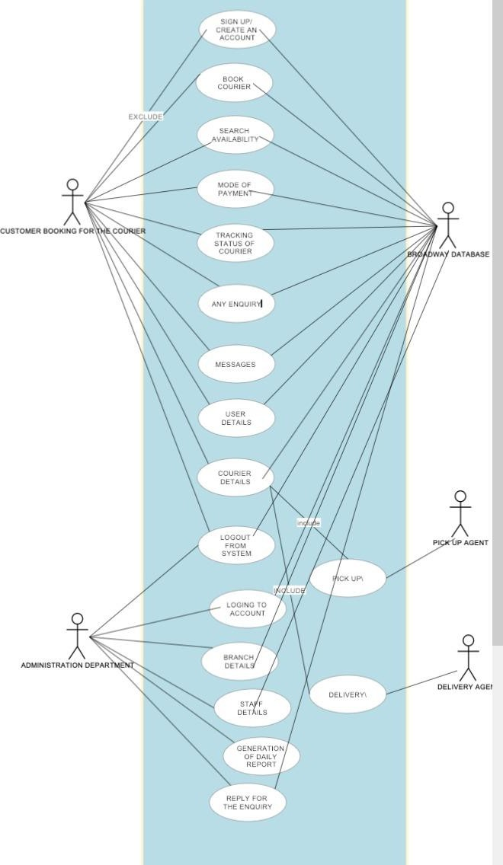

* 1. **Activity Diagrams**

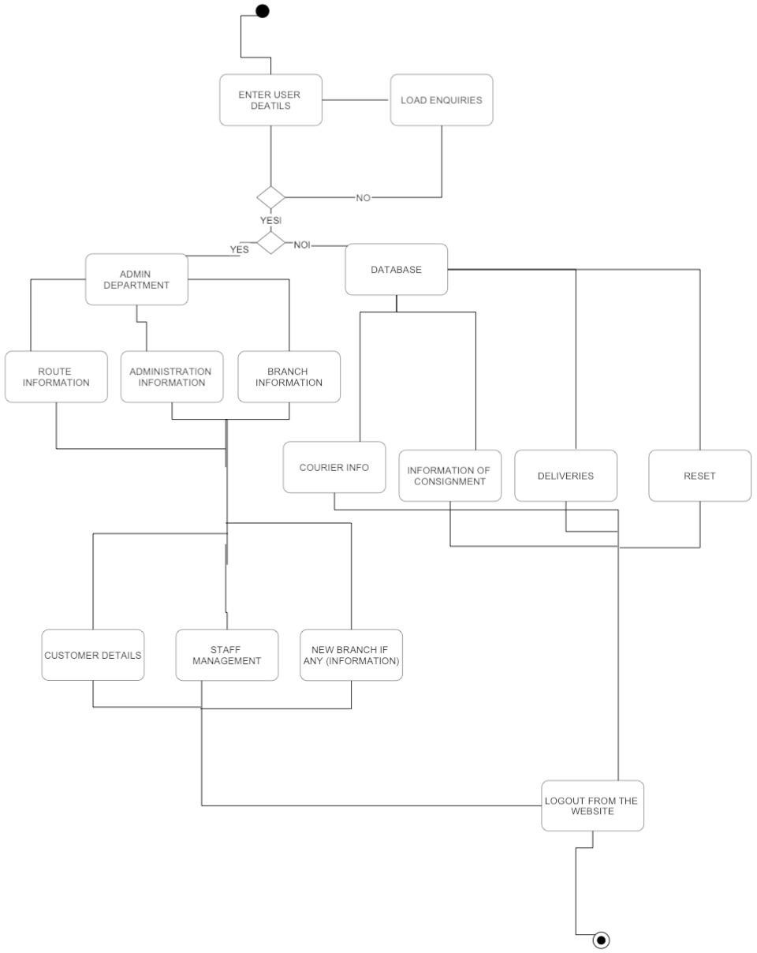

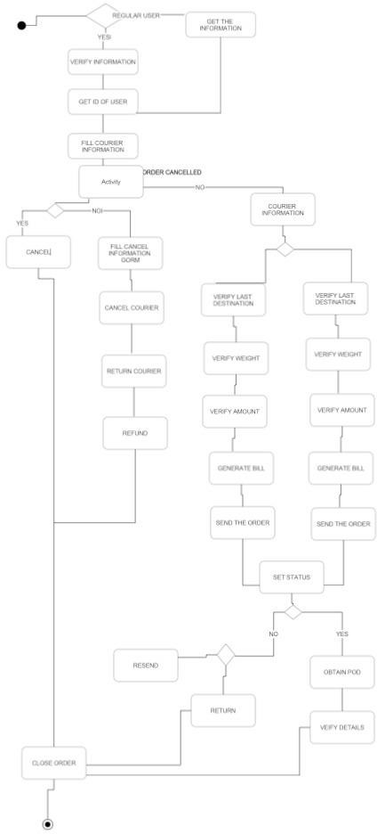

* 1. **Interface Design**

